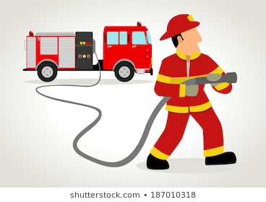

Enderby Fire Department
Dan Botkin Memorial Scholarship
Criteria:
A scholarship of $2000 is open to any 2025 graduate from A.L. Fortune going on to post-secondary. Funds are released with confirmation of registration in a full time post-secondary program. Must be used within two years of acceptance.
Applications are due to the Career Centre on April 9, 2025
Scholarship Applicant name: __________________________________________
Address: ___________________________________________________________
SIN: _______________________________________________________________
Graduating High School: ______________________________________________
School Contact: Michelle Hall and Tara Bryant
Please attach the following:
- Interim transcript (completed by office staff)
- Scholarship resume that outlines your interests and accomplishments, work experience, community involvement, extra-curricular activities.
- A letter addressed to the scholarship committee stating your future plans. This letter should include: your immediate plans following graduation, career goals, volunteer time, post-secondary schools applied/accepted and financial plans for supporting your educational goals.

